**DEPARTMENT OF INFORMATION SCIENCE & ENGINEERING**

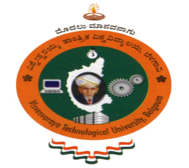

***Project Based LearningReport on***

“ ---------------------------------------------------------------------------

---------------------------------------------------------------------------------”

{title}

**BACHELOR OF ENGINEERING**

**in**

**INFORMATION SCIENCE AND ENGINEERING**

**by**

**Name USN**

*Under the Guidance of*

{Name of the Guide}

Designation



**BMS INSTITUTE OF TECHNOLOGY& MANAGEMENT**

BENGALURU-560064

2020-21

**BMS INSTITUTE OF TECHNOLOGY& MANAGEMENT**

YELAHANKA, BENGALURU- 560064

**DEPARTMENT OF INFORMATION SCIENCE & ENGINEERING**



**CERTIFICATE**

This is to certify that the project based learning entitled “-----------------------------------”is a bonafidework carried out by **Mr./Ms. ---------------------{Name1}{USN}, Mr./Ms. --------------------- {Name1}{USN}, Mr./Ms. --------------------- {Name1}{USN}, Mr./Ms. --------------------- {Name1}{USN}**during the academic year 2020-21. It is certified that all corrections/suggestions indicated for the Internal Assessment have been incorporated in the report deposited in the departmental library.

Signature of the guide Signature of the Coordinator Signature of the HOD

{Name of the guide} Prof Swetha M S/Dr. Geeta Patil Dr.Pushpa S K